APIS TO ENABLE

1. Cloud Source Repository Api - dockerhub
2. Kubernetes Api
3. Cloud build APi – Github

Google cloud:

1. gcloud config set project [PROJECT_ID]” - to set the project
2. gcloud projects list

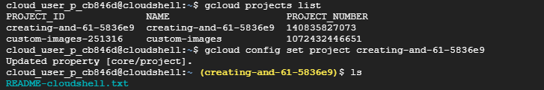

1. Yellow Highlighted one is the recent project
2. gcloud auth configure-docker (Docker command to authenticate docker registry)
3. various auths :

gcloud auth list

gcloud auth configure-docker

gcloud auth activate-service-account

gcloud auth login

gcloud auth print-access-token

gcloud auth print-identity-token

gcloud auth revoke

gcloud config list.

1. Build the docker image
2. Tag the image
3. docker tag nginx gcr.io/<PROJECT_ID>/nginx:v1

docker tag nginx gcr.io/creating-and-61-5836e9/nginx:v1

1. docker push gcr.io/creating-and-61-5836e9/nginx:v1

Manual Kubernetes cluster:

Create the Kubernetes Engine Cluster

Configure the zone:

gcloud config set compute/zone us-central1-a

Create the clusters:

gcloud container clusters create la-gke-1 --num-nodes=4

Get authentication credentials: ( Important to set the Kubeconfig)

gcloud container clusters get-credentials la-gke-1

Deploy the app (substituting your project ID where indicated):

kubectl run Nginx --image=gcr.io/<PROJECT_ID>/Nginx: v1 --port=80

Expose the Deployed Workload

Expose the deployment:

kubectl expose deployment Nginx --type=LoadBalancer --name=la-greetings-service --port=80 --target-port=80

Check its status:

kubectl get services Nginx

Namespaces:

kubectl create namespace hemanth

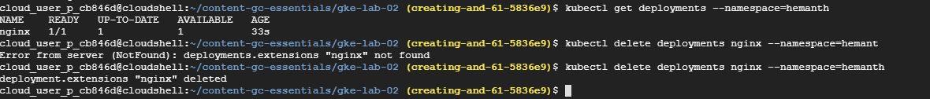

kubectl create deployment nginx --image=nginx --namespace=hemanth

deployment.apps/nginx created

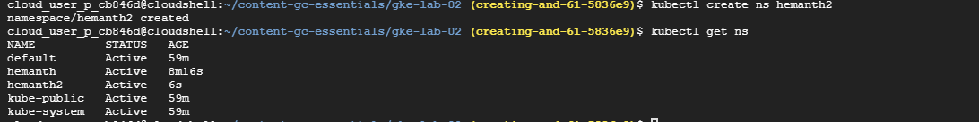

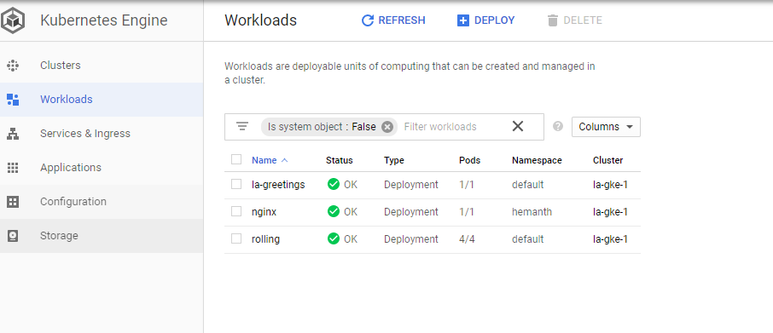

Service accounts:

<https://cloud.google.com/sdk/docs/authorizing>

<https://cloud.google.com/sdk/gcloud/reference/auth/activate-service-account>